CSCI 321 Lab 05

A new train company has decided that they would like to build a super fast train to connect as many of the major US cities as possible. They are entering phase 1 and have the approval to build train tracks in the places displayed in the map below.

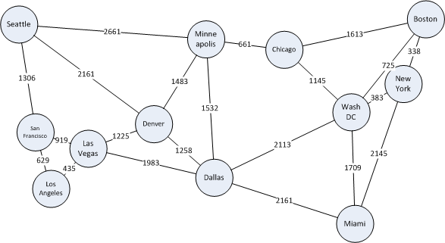

They have hired you to determine how they can keep each city connected, but spend the least amount of money building the tracks. The cost to connect each city is the weight provided on the edge. The weight is how many 1,000 of dollars it would cost. So, for example, San Francisco to Los Angeles would be $629,000.

You have decided that you would build a minimum spanning tree (MST) to solve the problem. You may use either Kruskals or Prims algorithm and you can use either an adjacency matrix or adjacency list. You may use resources on line, as long as you **cite your sources in comments**.

You should hand in a **zipped folder of your entire Eclipse project** to Blackboard before the due date. Sample output of a minimum spanning tree is included.

Seattle - San Francisco ($1,306,000.00)

San Francisco - Los Angeles ($629,000.00)

Los Angeles - Las Vegas ($435,000.00)

Las Vegas - Denver ($1,225,000.00)

Denver - Dallas ($1,258,000.00)

Denver - Minneapolis ($1,483,000.00)

Minneapolis - Chicago ($661,000.00)

Chicago - Washington DC ($1,145,000.00)

Washington DC - New York ($383,000.00)

New York - Boston ($338,000.00)

Washington DC - Miami ($1,709,000.00)

Total Cost: $10,572,000.00